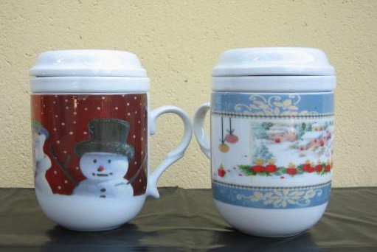  Christmas Collections – Infusion pots | 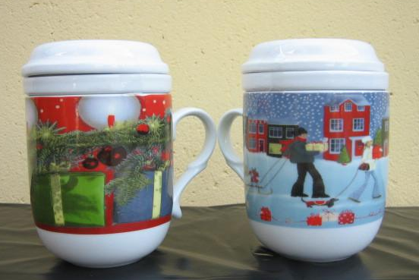
Infusion Pot Mod. 411 | Infusion Pot Mod. 411
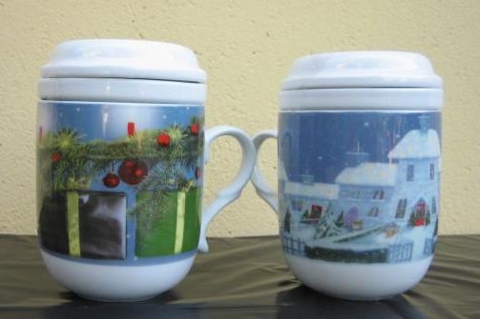 | 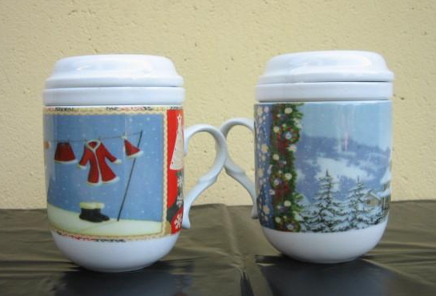
Infusion Pot Mod. 411 | Infusion Pot Mod. 411
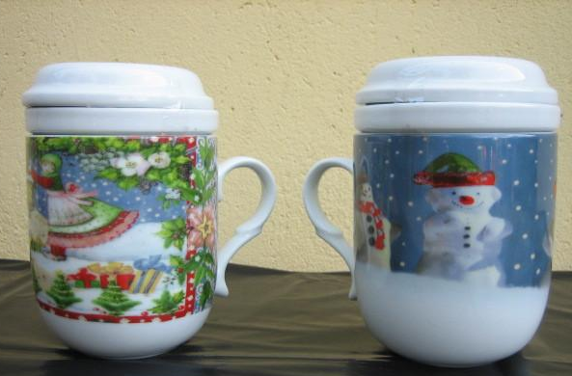 | 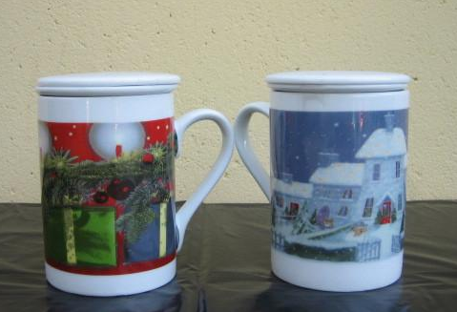
Infusion Pot Mod. 411 | Infusion Pot Mod. 412
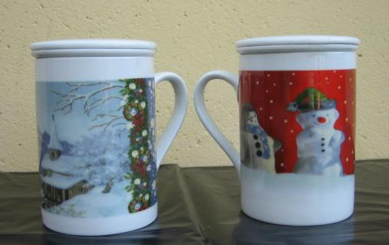 | 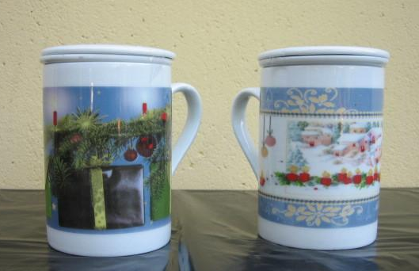
Infusion Pot Mod. 412 | Infusion Pot Mod. 412
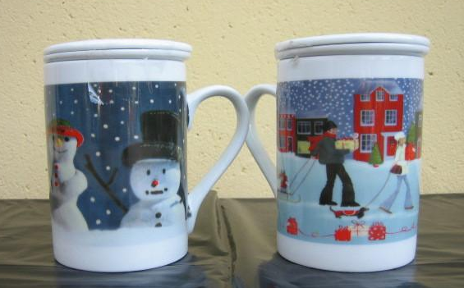 | 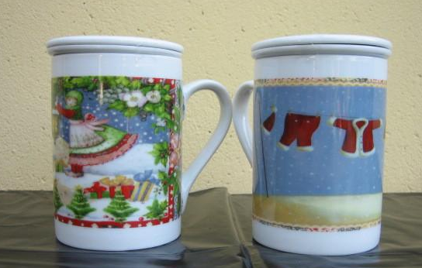
Infusion Pot Mod. 412 | Infusion Pot Mod. 412

