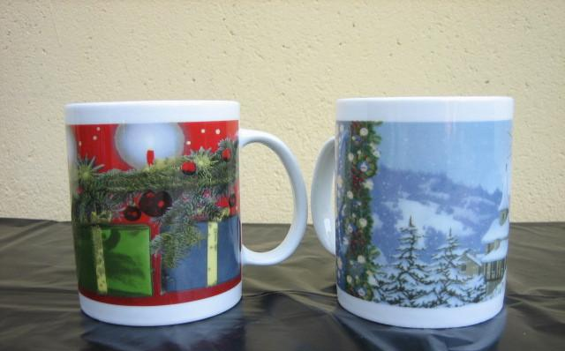  Mug. Mod. 0100 | 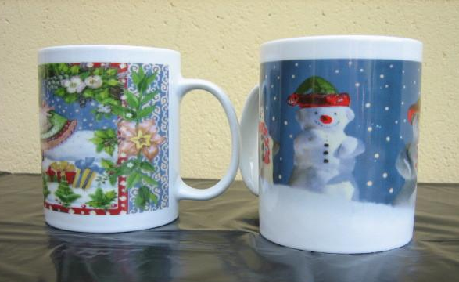  Mug Mod. 0100
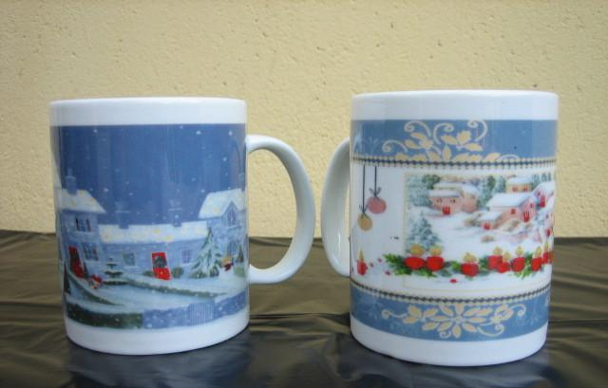  Mug. Mod. 0100 – Confezione | 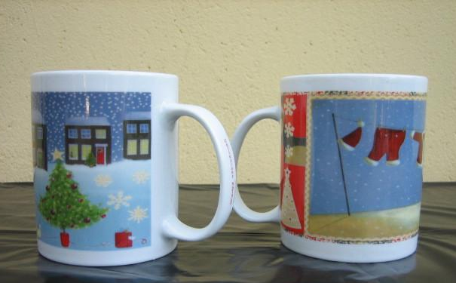  Mug Mod. 0100
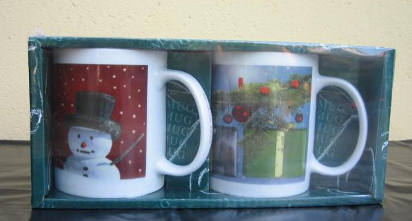
Mug. Mod. 0100 – Packing
Christmas Collections
Mugs

